**Functional Specification Document**

Employee Attendance Register

|  |  |  |  |  |
| --- | --- | --- | --- | --- |
| Index | | | | |
| 1 **Introduction** | | | | |
|  | 1.1 | | Project Overview |  |
|  | 1.2 | | Problem Statement |  |
|  | 1.3 | | User Classes and Characteristics |  |
|  | 1.4 | | Assumptions |  |
|  | 1.5 | | Goals |  |
| 2 Solution Overview | | | | |
|  | 2.1 | | Product Context |  |
|  | 2.2 | | Flow Diagram |  |
|  |  | 2.2.1 | Employee Check in |  |
|  |  | 2.2.2 | Employee Check out |  |
|  |  | 2.2.3 | HR Person |  |
|  | 2.3 | | Solution Specification |  |
|  | 2.4 | | Platform |  |
| 3 Use Cases | | | | |
| 4 System Configuration | | | | |

Introduction

1.1 Project Overview

Employee attendance register project change the traditional way of employee management and complexity in the processing of account/working hours/leave of a organization. This project stands in a single page application for all these operations, in addition to the feature this system can generate the report (attendance) of the employees at any time.

1.2 Problem Statement

The attendance systems in many organizations have difficulties in logging the employees logging in/logging out, Calculating total working hours, Add/Remove employees etc. Using of IOT and a biometric devices make the current system complex and give large cost to the organization. A centralized server system needed for the above components.

1.3 User Classes and Characteristics

1 - Employees

Punch in from the web portal by providing the emp id

2 - Hr Persons

Log In to the system with numerous operations such as viewing the employees, add/remove, generate reports, view current status of employees.

1.4 Assumptions

Induction of this system can reduce the challenging workload for the human resource team and the account team for the processing of their works.

1.5 Goals

Extending the current system with the accounting operation, such as salary processing, leave application submission, approval and other related operations.

Solution Overview

2.1 Product Context

A web based system is modern terminologies for the complex systems. In modern technologies can adapt to the changes in the future modifications and additional feature adding later.

2.2 Flow Diagram

 2.2.1 : Employee Check in

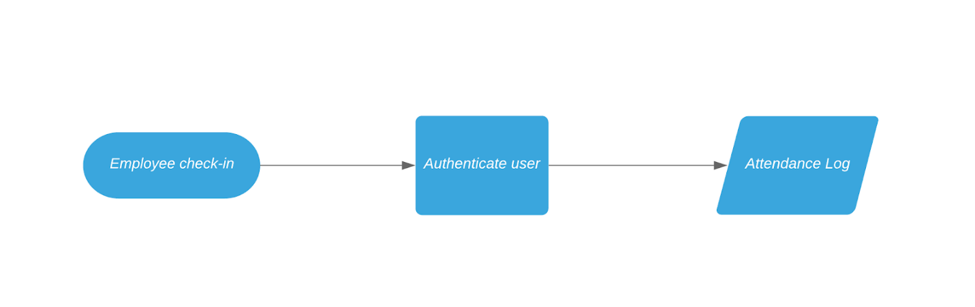

 2.2.2 : Employee Check out

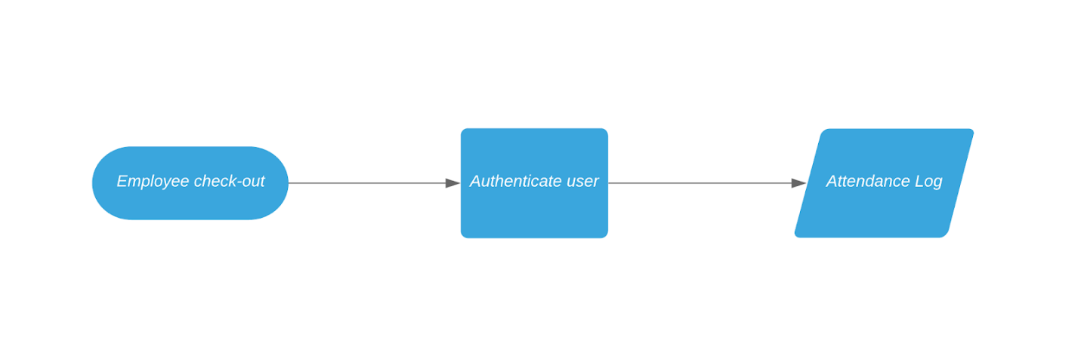

2.2.3 : HR Person

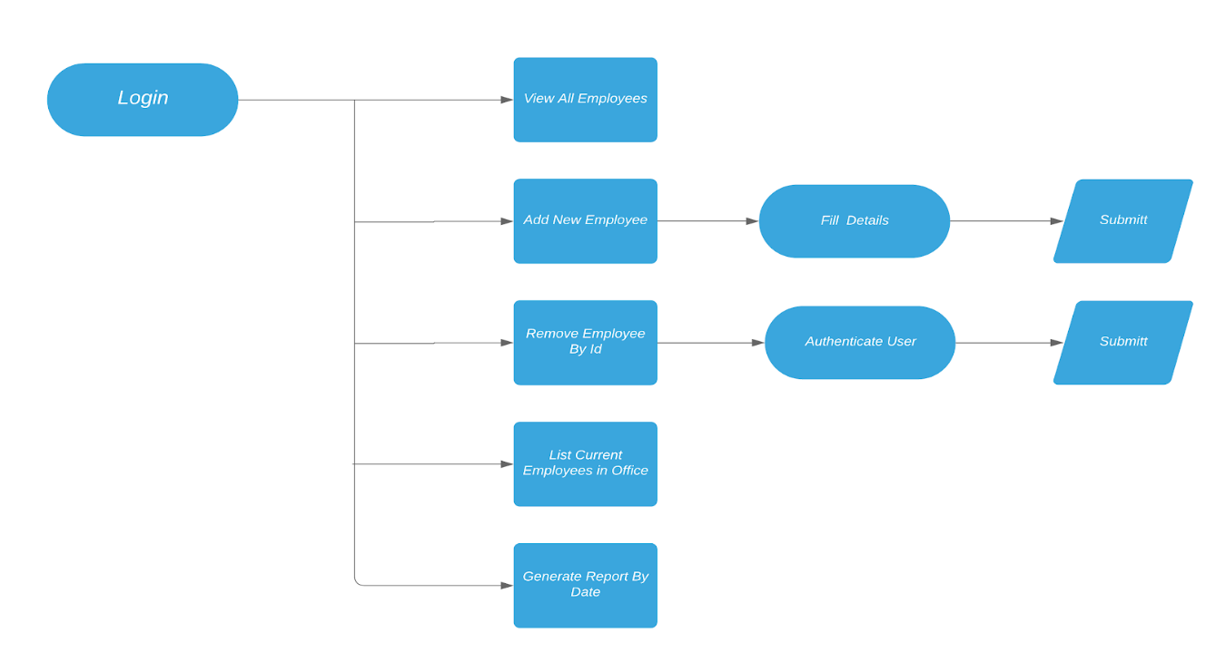

2.3 Solution Specification

2.4 Platform

Web based platform (browser/mobile)

Use Cases

A normal organization with employees more that 5, can able to access the system.

System Configurations

|  |  |  |  |
| --- | --- | --- | --- |
| OS Requirement | Version | Security | Server |
| All | 2018 above | Basic | Cloud |